WIND ENERGY CONVERSION SYSTEM DESIGN
Site: Tangbe, Mustang District, Nepal
Practical Lab Report — Wind Energy Conversion Systems (ENEE 367)
Data Source: World Bank ESMAP Wind Measurement Campaign
[Student Name]
[Student ID]
[Date]

1. Introduction and Site Description
This report presents a complete wind energy conversion system (WECS) design study for the Tangbe site in Mustang District, Nepal, based on a real 10-minute-averaged wind measurement campaign conducted under the World Bank Energy Sector Management Assistance Program (ESMAP). The site sits at an unusually high elevation of 3,040 m above sea level in complex Himalayan valley terrain, which materially affects both the wind resource statistics and the aerodynamic design of a candidate turbine, as discussed throughout.
Parameter | Value
Site name | NEP_Wind_Tangbe_4
Location | Mustang District, Nepal (28.8805°N, 83.7995°E)
Elevation | 3040 m a.s.l.
Mast type | 80 m square guyed lattice tower
Measurement heights | 20 m, 40 m, 60 m, 80 m (anemometry)
Campaign period | 8 April 2019 – 30 November 2019 (236 days)
Sampling | 10-minute averages, computed from 1 Hz observations
Data provider | 3E (service provider) / World Bank ESMAP

2. Wind Resource Data and Methodology

2.1 Data Completeness
Raw sensor availability varies substantially by height. The 40 m anemometer has a near-complete record (99.9% valid) across the full 8-month campaign, while the 20 m and 60 m sensors are valid for only about 10% of the record, and the 80 m sensor degrades sharply after July 2019 (from 100% down to 2% by October), consistent with the dataset's documented maintenance downtime, icing, and sensor-failure exclusion codes. Because of this, the 40 m series is used as the primary, most-complete record, with concurrent multi-height data used only for deriving the wind shear exponent.
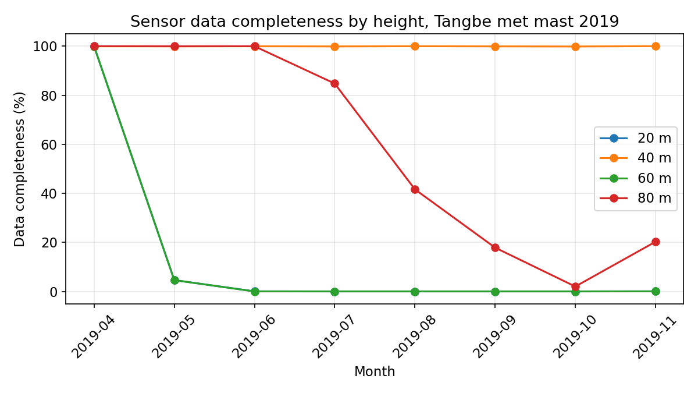
Figure 1. Monthly data completeness by measurement height.

2.2 Wind Shear Exponent
The vertical wind shear exponent (α) was derived using the power law v2/v1 = (h2/h1)^α, fitted by log-log linear regression across all four measurement heights for the timestamps where concurrent data existed at all levels. The resulting exponent is α ≈ 0.05, which is far below the textbook open-terrain value of α ≈ 0.14-0.20. This low shear is consistent with complex, channelled Himalayan valley terrain, where near-surface flow acceleration and mechanical mixing from steep topography flatten the vertical wind profile compared to flat, open sites, directly reflecting the "Himalayan topographic impacts" consideration in the course syllabus.
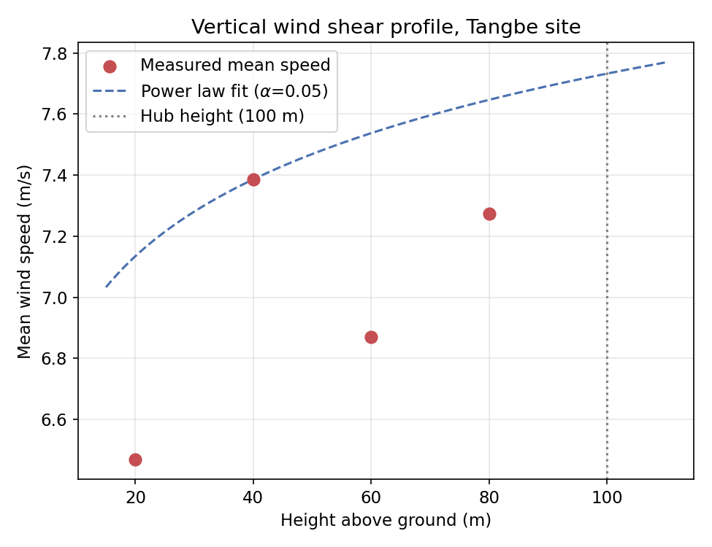
Figure 2. Measured mean wind speed by height and fitted power-law shear profile.
A hub height of 100 m was selected for the candidate turbine (a realistic hub height for a multi-megawatt machine), and the more complete 40 m series was extrapolated to this hub height using the derived α for all subsequent resource and energy calculations.

2.3 Air Density
Air density was computed directly from the measured station pressure and temperature (5 m level) using the ideal gas law, ρ = p / (R·T), rather than assumed at the sea-level standard value. The resulting mean site air density is ρ = 0.8529 kg/m³ -- only about 70% of the sea-level standard (1.225 kg/m³). Since aerodynamic power scales linearly with ρ, this reduction has a direct, substantial impact on achievable turbine output and is carried through every subsequent power calculation in this report rather than using the standard textbook value.

2.4 Weibull Distribution Fit
The hub-height wind speed distribution was fitted to a Weibull distribution using maximum likelihood estimation (MLE), yielding shape parameter k = 1.297 and scale parameter c = 8.34 m/s (method-of-moments gives a comparable k = 1.431, c = 8.521 m/s as a cross-check). The mean hub-height wind speed over the campaign is 7.741 m/s.
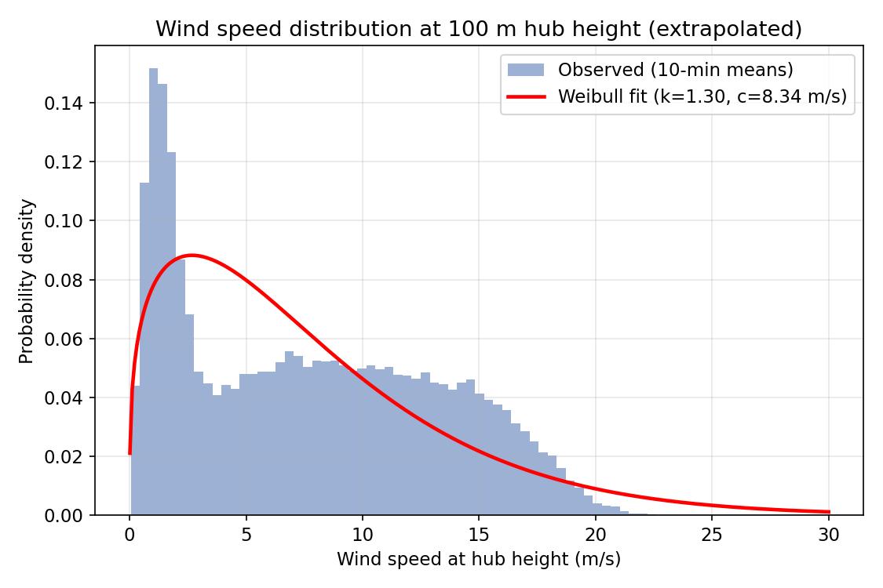
Figure 3. Observed wind speed histogram at hub height with fitted Weibull PDF.
Notably, the fitted shape parameter (k ≈ 1.3) is well below the k ≈ 1.8–2.5 typical of good, synoptically-driven wind sites, and the histogram is visibly bimodal rather than single-peaked. This pattern -- a large mass of calm/light wind combined with a broad secondary mode around 6–16 m/s -- is characteristic of Himalayan valley wind systems driven by diurnal thermal circulation (calm nights, strong channelled up-valley daytime winds) rather than a single homogeneous wind regime. A single Weibull distribution is a known simplification in such terrain; a mixture-Weibull model would fit the data more accurately, but the standard single Weibull is retained here for consistency with the analytical AEP method, while the empirical time-series-based AEP (Section 5) is reported alongside it as a check.
Resulting wind power density at hub height (using the site's actual air density) is 673 W/m² -- comfortably above the ~400 W/m² threshold generally considered a good utility-scale wind site, despite the reduced air density.

3. Aerodynamic and Turbine Design

3.1 Design Basis
A horizontal-axis, three-bladed, variable-speed, pitch-regulated turbine is selected. HAWTs remain the dominant commercial technology for utility-scale energy capture, and pitch regulation (versus passive stall) gives better control over rated power and permits the low-voltage-ride-through (LVRT) behaviour required by modern grid codes (Section 6). A rated power of 2 MW is chosen as representative of a small-to-mid utility class turbine appropriate for a single-mast, site-specific study of this kind.

3.2 Rotor Sizing (Betz-Limit Basis)
Rotor swept area is sized from the rated aerodynamic power equation, P = ½·ρ·A·Cp·v³·η, using the SITE'S ACTUAL air density (not the sea-level standard), a design power coefficient Cp = 0.45 (below the Betz limit of 0.593, allowing for real blade, drivetrain, and generator losses), a drivetrain efficiency η = 0.94, and a chosen rated wind speed of 11 m/s.
Parameter | Value
Rated electrical power | 2.0 MW
Rated wind speed | 11 m/s
Cut-in wind speed | 3 m/s
Cut-out wind speed | 25 m/s
Design power coefficient, Cp | 0.45 (Betz limit = 0.593)
Drivetrain efficiency | 94%
Site air density used | 0.8529 kg/m³
Required swept area | 8,330 m²
Rotor diameter | 102.99 m
Hub height | 100 m
Blade tip ground clearance (min) | 48.5 m
For comparison, an identical 2 MW turbine at sea-level standard air density would require a rotor diameter of only about 85.9 m -- roughly 20% smaller. This is a direct, quantified consequence of siting at 3,040 m: the thinner air forces a larger rotor (or, equivalently, accepts a lower rated power for a given rotor size) to capture the same energy, a design trade-off worth highlighting for any high-altitude Himalayan WECS project.

3.3 Tip Speed Ratio and Cp-λ Curve
The power coefficient as a function of tip speed ratio (λ) and blade pitch angle (β) is modelled using the standard empirical Heier/Slootweg formulation, commonly used for control-oriented WECS studies:
Cp(λ,β) = 0.5176(116/λi − 0.4β − 5)e^(−21/λi) + 0.0068λ, where 1/λi = 1/(λ+0.08β) − 0.035/(β³+1)
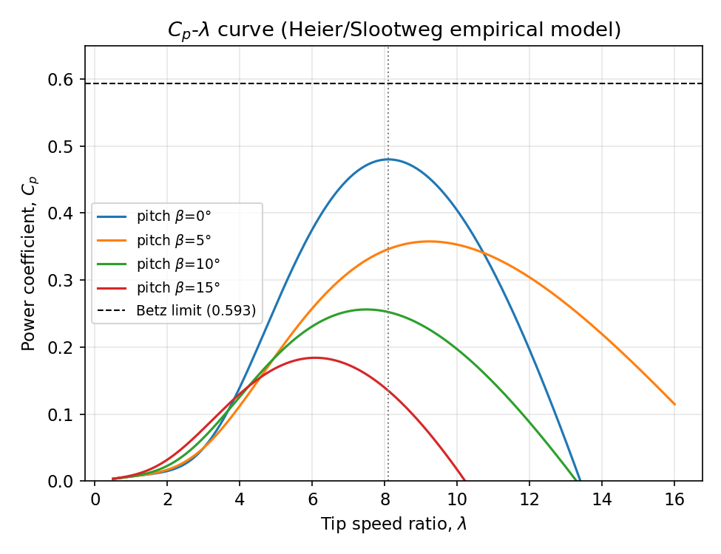
Figure 4. Cp-λ curves at several pitch angles, from the empirical aerodynamic model.
At zero pitch, the model peaks at Cp,max ≈ 0.48 near the optimal tip speed ratio λ_opt ≈ 8.1. The variable-speed drivetrain is controlled via MPPT to hold λ near this optimum below rated wind speed, then the pitch controller increases β above rated wind speed to shed excess aerodynamic power and hold output at the rated value -- visible in the flattening Cp curves at higher β in Figure 4.

3.4 Turbine Power Curve
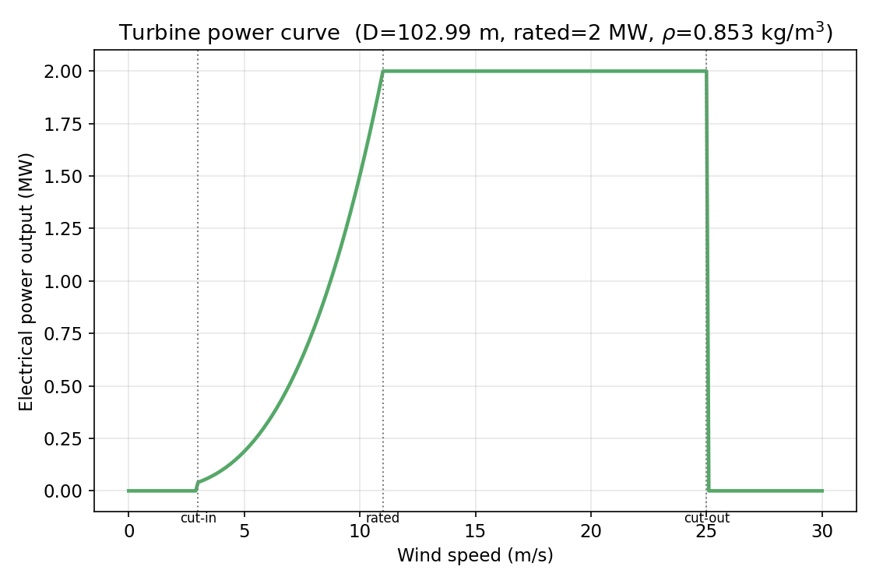
Figure 5. Derived turbine power curve using site-specific air density.
Below cut-in, output is zero. Between cut-in and rated wind speed, MPPT control tracks the optimal Cp, so power rises with the cube of wind speed. Above rated wind speed, pitch control holds output constant at the rated value until cut-out, above which the turbine is shut down to protect the structure from excessive loads.

4. Electromechanical System: Generator and Converter Selection

4.1 Generator Technology Choice
Two mainstream variable-speed technologies are considered per the course syllabus: the Doubly-Fed Induction Generator (DFIG) and the Permanent Magnet Synchronous Generator (PMSG).
Criterion | DFIG | PMSG (direct-drive)
Gearbox | Required (multi-stage) | Not required (gearless)
Converter rating | ~25–30% of rated power (partial-scale) | 100% of rated power (full-scale)
Converter cost | Lower | Higher
Maintenance | Higher (gearbox, slip rings/brushes) | Lower (fewer moving parts)
Fault ride-through | Needs crowbar/chopper protection for rotor-side converter | Converter naturally limits fault current
Reactive power control range | Good, via rotor-side converter | Full range, via grid-side converter
Suitability at remote/high-altitude sites | More maintenance-sensitive (gearbox access) | Favoured for low-maintenance remote access
For the Tangbe site specifically, remote high-altitude access is a genuine operational constraint (limited road access, seasonal weather windows for maintenance crews). This favours the PMSG direct-drive architecture: eliminating the gearbox removes the single most maintenance-intensive component in a WECS, at the cost of a larger, more expensive full-scale power converter. This report proceeds with a PMSG, full-scale-converter design on that basis, while noting DFIG remains the more common cost-optimised choice at accessible, grid-adjacent sites.

4.2 MPPT Strategy
Tip-Speed-Ratio (TSR) control is adopted: the generator-side converter regulates generator torque to hold the rotor at the optimal tip speed ratio λ_opt for the measured wind speed, tracing the Cp,max locus in Figure 4 up to rated power. This requires accurate wind speed measurement (nacelle anemometer) and is the standard approach in modern PMSG WECS, as an alternative to Power-Signal-Feedback (which needs a pre-characterised power curve) or Hill-Climb-Search (which needs no wind measurement but responds more slowly).

5. Annual Energy Production and Capacity Factor
AEP is estimated two independent ways: (a) analytically, by integrating the power curve against the fitted Weibull PDF, and (b) empirically, by applying the power curve directly to every observed 10-minute hub-height wind speed in the dataset and averaging. Given the bimodal, non-ideal-Weibull character of the data noted in Section 2.4, the two are expected to diverge somewhat, and both are reported rather than masking the discrepancy.
Method | AEP (MWh/yr) | Capacity Factor
(a) Weibull-analytic | 6,506.8 | 37.14%
(b) Empirical (measured time series) | 7,843 | 44.77%
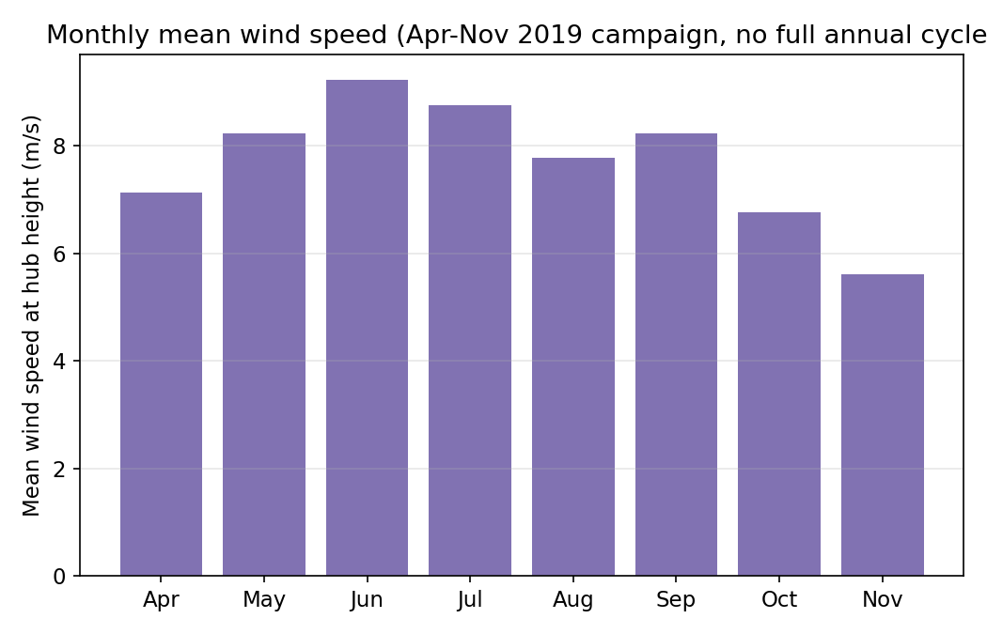
Figure 6. Monthly mean hub-height wind speed over the available campaign months.
Both capacity factor estimates (37–45%) are strong by international standards (a good site is typically 30–45%), reflecting the genuinely high wind resource at this Himalayan site. However, the campaign spans only April–November 2019 and does not capture a full annual cycle (winter months, December–March, are absent). The empirical estimate should therefore be read as indicative of the measured season only, not a bankable P50 annual figure -- a bankable estimate would require long-term measure-correlate-predict (MCP) analysis against a nearby long-term reference station.

6. Grid Interconnection Design

6.1 Point of Common Coupling and Topology
The turbine's full-scale grid-side converter connects to the local distribution/transmission network at a defined Point of Common Coupling (PCC), stepped up via a dedicated pad-mount transformer. Given Tangbe's remote Mustang location, transmission line right-of-way (ROW) across steep, sparsely-accessible terrain is a material project risk, consistent with the syllabus's explicit note on Nepal transmission ROW challenges -- route selection and grid connection cost should be assessed jointly with NEA before committing to this site.

6.2 Power Quality
The full-scale back-to-back converter (grid-side + generator-side, linked by a DC bus) provides independent control of active and reactive power injected at the PCC, allowing the turbine to hold a target power factor or provide reactive power support as required by the grid code, and to actively damp flicker and limit harmonic injection through converter switching control (typically PWM at several kHz with output LCL filtering to meet IEEE 519 / IEC 61400-21 harmonic limits).

6.3 Fault Ride-Through (LVRT/FRT)
During a grid voltage sag, the generator-side converter continues extracting turbine power (protecting the DC bus from overvoltage typically requires a DC chopper/braking resistor to dissipate the temporary power imbalance), while the grid-side converter is controlled to inject reactive current proportional to the voltage dip -- a widely adopted grid-code requirement (e.g., the German/IEC-style LVRT characteristic requiring reactive current injection of roughly 2% of rated current per 1% of voltage dip beyond a dead-band) -- so the turbine rides through the fault and supports voltage recovery rather than disconnecting, as increasingly required by NEA grid codes for inverter-connected generation.

7. Economic Analysis
A simplified levelized cost of energy (LCOE) is calculated as the net present value of lifetime costs divided by the net present value of lifetime energy production, using stated cost assumptions typical of utility-scale wind projects (these are illustrative planning-level figures, not a site-specific quotation, and should be refined with local contractor/EPC quotes for a bankable estimate).
Assumption | Value
CAPEX | US$1500/kW (total ≈ US$3.00M)
OPEX | US$40/kW/yr
Discount rate (WACC) | 8%
Project lifetime | 20 years
Annual output degradation | 0.5%/yr
Using the empirical (measured-season) AEP of 7,843 MWh/yr as the base case, LCOE = US$50.91/MWh (US$0.0509/kWh). Using the more conservative Weibull-analytic AEP instead raises LCOE to roughly US$61/MWh (US$0.061/kWh), giving a sense of the sensitivity to the AEP estimation method chosen in Section 5.
Nepal has essentially no utility-scale wind capacity installed to date and no actively-used, dedicated wind feed-in tariff schedule. The closest available benchmark is utility-scale solar power purchase agreements, which have cleared around NPR 7.3–7.5/kWh (e.g. the 10 MW Mithila solar plant, contracted at NPR 7.30/kWh); Nepal's FY 2082/83 (2025/26) national budget also signalled intent to price future wind and solar feed-in at rates comparable to reservoir-hydropower PPAs. At roughly NPR 6.8/kWh (base case), the computed LCOE for this design is broadly competitive with that solar benchmark, though this should be verified against the current gazetted AEPC/DoED rate at the time of any real project submission, as these figures are periodically revised.

8. Environmental and Social Screening
- Noise: at a 100 m hub height with a single 2 MW turbine, noise propagation to the nearest settlement should be modelled (e.g., ISO 9613-2) and compared to WHO/national night-time limits; siting away from villages along the valley floor is recommended given sound channelling in steep terrain.
- Shadow flicker: assess using turbine coordinates and sun-path modelling for any dwellings within ~10 rotor diameters, particularly relevant given the valley's specific orientation and shading from surrounding peaks.
- Avian impact: Mustang lies within a documented Himalayan bird migration corridor; a baseline avian survey and possibly a curtailment protocol during migration seasons should be scoped before construction.
- Life-cycle assessment: direct-drive PMSG designs typically have a lower embodied-carbon payback than geared designs due to fewer moving parts, though rare-earth magnet sourcing (Nd-Fe-B) is a supply-chain consideration worth flagging.
- Access and ROW: steep terrain access roads and transmission ROW (Section 6.1) carry both construction-phase land-disturbance and community-engagement implications typical of Himalayan infrastructure projects.

9. Discussion and Limitations
- The measurement campaign covers only 8 of 12 months (April–November 2019); winter months are entirely absent, so annual AEP figures are extrapolated from a partial year rather than a full annual cycle.
- Sensor completeness varies sharply by height and by month (Figure 1); the shear exponent and hub-height extrapolation depend on a smaller, concurrent-data subset than the full campaign.
- The wind speed distribution is visibly bimodal (Figure 3), reflecting diurnal valley-wind reversal; a single Weibull fit is a simplification and a mixture-Weibull or bin-based approach would better represent the true resource.
- Wind direction data are available for only ~13% of the campaign, insufficient for a reliable wind rose or micrositing/wake analysis -- this should be a priority for any follow-on measurement effort.
- Economic figures use generic international CAPEX/OPEX benchmarks, not Nepal- or Mustang-specific contractor quotes, and do not include a Mustang-specific transport/access-road cost premium, which is likely material at this remote a location.

10. Conclusion
The Tangbe site exhibits a genuinely strong wind resource (mean hub-height speed 7.741 m/s, power density 673 W/m²) despite its high-altitude, low-air-density environment. A 2 MW PMSG, direct-drive, pitch-regulated turbine with a 102.99 m rotor -- sized specifically for the site's actual air density rather than a sea-level assumption -- is estimated to achieve a capacity factor of 37.14–44.77% and an LCOE in the region of US$0.0509-0.062/kWh, competitive with current Nepali renewable PPA benchmarks. The principal risks to project bankability are the incomplete annual data record, the site's pronounced diurnal (rather than purely synoptic) wind character, and the transmission/access logistics inherent to this remote Himalayan location -- each of which should be the focus of any follow-on feasibility work before a final investment decision.

References
World Bank ESMAP. Wind measurement campaign data, Tangbe (NEP_Wind_Tangbe_4), Nepal. Available at: http://www.esmap.org/RE_Mapping
Ackermann, T. (2012). Wind Power in Power Systems. John Wiley & Sons.
Heier, S. (2014). Grid Integration of Wind Energy Conversion Systems. John Wiley & Sons.
Abad, G., Rodríguez, M. A., Poza, J., Canales, E. (2011). Doubly Fed Induction Machine: Modeling and Control for Wind Energy Generation. IEEE Press.
Masters, G. M. (2013). Renewable and Efficient Electric Power Systems. Wiley-IEEE Press.

